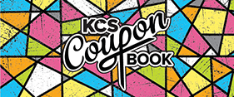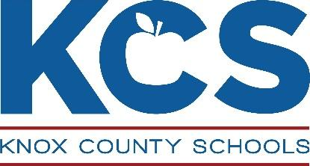

Dear Adrian Burnett Families,

We are pleased to announce this year’s Knox County Schools Coupon Book campaign will launch on **Thursday, September 24, 2020** and run until **Thursday, October 22, 2020**. The Coupon Book fundraiser is the school district’s biggest – raising more than $1.4 million last year – and we couldn’t do it without your support!

This year’s Coupon Book features several new merchants, in addition to our partners who continue to return year after year. We are very thankful for all of the businesses in Knox and Sevier counties that have committed to giving back to our students, teachers and schools.

After more than three decades, the Coupon Book remains a great deal at only **$10**. For every book sold, the majority of sales stays at our school – an amazing gift that directly benefits your student. And this year, you have the option of purchasing the Coupon Book online. *(See the back of this flyer for information about using SchoolCashOnline.)*

Our goal for 2020 is to sell **1,500** or more Coupon Books. Be sure to check out this year’s incentives! The Art Contest is new this year for every student who sells 5 books. Each school winner will receive two (2) large posters of their artwork, one for the school to display and one for them to take home. There will be four (4) overall district winners: Primary, Elementary, Middle and High School winners will receive a prize package with over $100 worth of coupons and gift cards, which will be presented at the Main Event celebration on November 13.

We will be sending home information about the campaign, including our additional school-level incentives, next week.

If we succeed in this effort, the money will be used as follows:

* Update and replace technology
* Purchase instructional materials
* Maintain our campus

**Thank you** again for all you do to support our school!

Sincerely,

Stephanie Prince

Principal